**Week-6**

**ReactJS-HOL**

**6. ReactJS-HOL hands-on**

**Cognizant Academy teams want to maintain a list of trainers along with their expertise in a SPA using React as the technology. You are assigned the task of creating this React app.**

**The following trainers’ data application will deal.**

1. **T-ID**
2. **Name**
3. **Phone**
4. **Email**
5. **Stream**
6. **Skills**

**Code:**

**Trainer.js**

class Trainer {

    constructor (trainerId, name, email, phone, technology, skills) {

        this.trainerId = trainerId;

        this.name = name;

        this.email = email;

        this.phone = phone;

        this.technology = technology;

        this.skills = skills;

    }

}

export default Trainer;

**TrainersMock.js**

import Trainer from "./Trainer";

const TrainersMock = [

    new Trainer('t-syed8',

                'Syed Khaleelullah',

                'Khaleelullah@cognizant.com',

                '97676516962',

                '.NET',

                ['C#', 'SQL Server', 'React', '.NET Core']

    ),

    new Trainer('t-jojo',

                'Jojo Jose',

                'jojo@cognizant.com',

                '9897199231',

                'Java',

                ['Java', 'JSP', 'Angular', 'Spring']

    ),

    new Trainer('t-elisa',

                'Elisa Jones',

                'elisa@cognizant.com',

                '9871212235',

                'Python',

                ['Python', 'Django', 'Angular']

    )

]

export default TrainersMock;

**TrainersList.js**

import React from "react";

import { Link } from "react-router-dom";

function TrainersList({ trainers }) {

  return (

    <div>

      <h2>Trainers List</h2>

      <ul>

        {trainers.map((trainer, index) => {

          return (

            <li key={trainer.trainerId || index}>

              <Link to={`/trainers/${trainer.trainerId}`}>

                {trainer.name}

              </Link>

            </li>

          );

        })}

      </ul>

    </div>

  );

}

export default TrainersList;

**TrainersLists.js**

import { useParams } from "react-router-dom";

import trainersMock from "./TrainersMock";

function TrainerDetail() {

  const { id } = useParams();

  const trainer = trainersMock.find((t) => t.trainerId === id);

  if (!trainer) {

    return <h2>Trainer Not Found</h2>;

  }

  return (

    <div>

      <h2>Trainers Details</h2>

      <p><strong>{trainer.name} ({trainer.technology})</strong></p>

      <p>{trainer.email}</p>

      <p>{trainer.phone}</p>

      <ul>

        {trainer.skills.map((skill, index) => (

          <li key={index}>{skill}</li>

        ))}

      </ul>

    </div>

  );

}

export default TrainerDetail;

**App.js**

import './App.css';

import { BrowserRouter, Routes, Route, Link } from "react-router-dom";

import Home from "./Home";

import TrainersList from "./TrainersList";

import TrainerDetail from "./TrainersDetails";

import TrainersMock from "./TrainersMock";

function App() {

  return (

    <BrowserRouter>

      <div>

        <h1>My Academy Trainers App</h1>

        <nav>

          <Link to="/">Home</Link> | <Link to="/trainers">Show Trainers</Link>

        </nav>

        <Routes>

          <Route path="/" element={<Home />} />

          <Route path="/trainers" element={<TrainersList trainers={TrainersMock} />} />

          <Route path="/trainers/:id" element={<TrainerDetail />} />

        </Routes>

      </div>

    </BrowserRouter>

  );

}

export default App;

**Output:**

**Home page:**

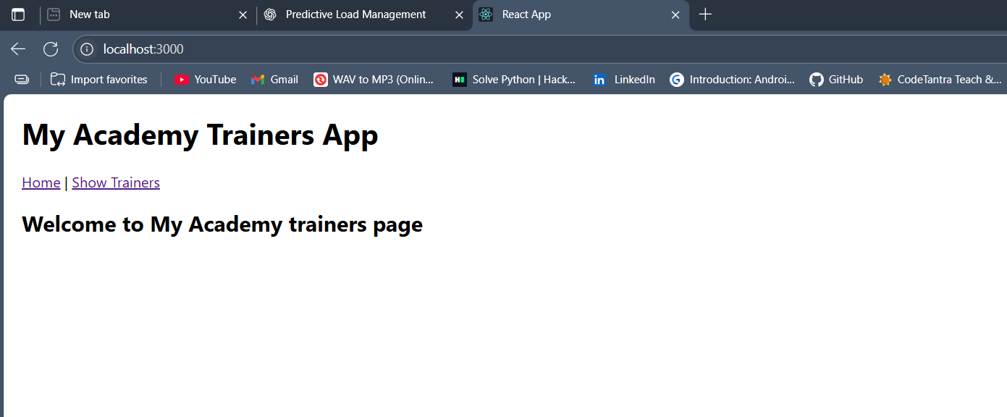

**Trainers page:**

